Graphical Modeling And Simulation Of Inner Coma Outgassing Jets From Comet

**VIII SEMSTER MINI PROJECT – B.TECH (IT) – IIIT ALLAHABAD**



Guidance of-

Dr.Pavan Chakraborty

Submitted by-

Arijit Das(RIT2012013)

DECLARATION

I hereby declare that the project work entitled “Graphical Modeling and Simulation of Inner Coma Outgassing Jets from Comet” submitted to the IIIT Allahabad, is a record of an original work done by me under the guidance of Dr. Pavan Chakraborty and has not been submitted to any other University or Institute or published earlier.

Place: IIIT Allahabad Arijit Das(RIT2012013)

CERTIFICATE FROM THE MENTOR

It is certified that this project report “Graphical Modeling and Simulation of Inner Coma Outgassing Jets from Comet ” of mini project taken in VIII semester is the bonafide work of “Arijit Das(RIT2012013**”** who carried out the project work under my supervision.

Dr. Pavan Chakraborty,

Faculty In-charge (Ph.D. Cell),

Faculty Coordinator (IT),

IIIT – Allahabad, Allahabad

ACKNOWLEDGEMENTS

We would like to express our sincere gratitude to all the people who helped and supported me. This project would not be complete without the thoughtful guidance of our project mentor, Dr. Pavan Chakraborty.

Place: Allahabad **Arijit Das (RIT2012013)**

ABSTRACT

Modeling and Simulation of Outgassing Jets from Comet

*by*

*Arijit Das*

Chair : Dr. Sudip Sanyal.

Mentor : Dr. Pavan Chakravarty

An outgassing jet model is presented in this project in support of further comet investigation and analysis as well as to visualize the model. The outgassing jet is modelled as an emission cone while the comet nucleus is modelled as a uniform density triaxial shaped. The heliocentric orbit motion as well as in the strength of the outgassing jet are accounted for in the equations of motion. This model is used for predicting the rotational evolution of a comet nucleus as a result the outgassing jets’ reactive torque. A model for the rotational evolution of a comet nucleus is presented and predicts possible levels of rotational excitation for a comet nucleus under torques produced by multiple discrete outgassing jets located on the surface. An analytical theory for the secular solution to the rotational motion of comets with an axis of symmetry is derived and used to predict rotational state changes over multiple perihelion passages. A method of characterizing the comet nucleus dynamics to predict the end state of the rotation is found from the averaged equations. Applications of these analytical results to predict the stochastic evolution of a comet nucleus rotation are outlined.

**CONTENT**

1. Introduction
2. Problem Statement
3. Proposed Approach
4. Activity Chart
5. Implementation
6. Description of Hardware and Software Requirements
7. Result
8. Limitations
9. Future Scope of Project
10. References

1.Introduction

Beginning in May 1996, several observers reported multiple jets from Comet Hale–Bopp. Manzini et al. (1996) reported several secondary jets in August 1996, which gave the comet the appearance of a porcupine. Sekanina and Boehnhardt (1997, 1999) interpreted jet pairs (one pair per source) as the boundaries of fan-shaped formations described by dust ejected from the sources continually between local sunrise and sunset. To explain the observations during May–November 1996, they proposed two models, one with six sources and a spin axis undergoing a complex motion and another with a fixed spin axis and a large diurnal dust ejection fluctuations for one of the jets. Sekanina (1998a) used Monte Carlo computer simulation to show that the dust source producing the south westerly halo in the timeresolved image sequences by Jorda et al. (1999) is located at +55◦ and derived the pole positions. Samarasinha et al. (1999) constrained the direction of the spin axis of the nucleus referred to the ecliptic. Vasundhara et al. (1999) fitted the jets and shells in 12 images of the comet obtained at the observatory of the Naturwissenschaftlicher Verein Osnabr¨uck during September 1996 to May 1997 to derive the latitude of the jet sources and pole positions. We attempt here to model the jets using the observations from the Vainu Bappu Observatory from October 1996 to October 1997 to determine the location of the active regions and the pole positions.

* 1. Comet Model Description

The comet nucleus and its environment are complex systems, assumptions on the characteristics of the comet body and the outgassing jet geometry will be made as simplifications to the true comet properties.

**Definition** : A **comet** is an icy small Solar System body that, when passing close to the Sun, heats up and begins to outgas, displaying a visible atmosphere or coma, and sometimes also a tail. These phenomena are due to the effects of solar radiation and the solar wind upon the nucleus of the comet. Comet nuclei range from a few hundred metres to tens of kilometres across and are composed of loose collections of ice, dust, and small rocky particles. The coma and tail are much larger and, if sufficiently bright, may be seen from the Earth without the aid of a telescope.

Physical Characteristics:

1. Nucleus: The solid, core structure of a comet is known as the nucleus. Cometary nuclei are composed of an amalgamation of rock, dust,water ice, and frozen gases.Some comets may have a higher dust content, leading them to be called "icy dirtballs".[[14]](https://en.wikipedia.org/wiki/Comet#cite_note-14) Research conducted in 2014 suggests that comets are like "deep fried ice cream", in that their surfaces are formed of dense crystalline ice mixed with organic compounds, while the interior ice is colder and less dense.

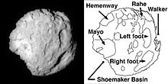

Figure: Nucleus of Comet

1. **Coma:** The streams of dust and gas thus released form a huge and extremely thin atmosphere around the comet called the "coma", and the force exerted on the coma by the Sun's radiation pressure and solar wind cause an enormous "tail" to form pointing away from the Sun.

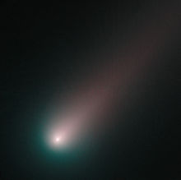

**Figure: Coma**

1. **Tails:** In the outer Solar System, comets remain frozen and inactive and are extremely difficult or impossible to detect from Earth due to their small size. Statistical detections of inactive comet nuclei in the Kuiper belt have been reported from observations by the Hubble Space Telescope. As a comet approaches the inner Solar System, solar radiation causes the volatile materials within the comet to vaporize and stream out of the nucleus, carrying dust away with them.
2. **Jets:** Uneven heating can cause newly generated gases to break out of a weak spot on the surface of comet's nucleus, like a geyser. These streams of gas and dust can cause the nucleus to spin, and even split apart. In 2010 it was revealed dry ice (frozen carbon dioxide) can power jets of material flowing out of a comet nucleus. This is known because a spacecraft got so close that it could see where the jets were coming out, and then measure the infrared spectrum at that point which shows what some of the materials are.

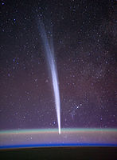

Figure: Jets from Comet Hale-Bopp

2.Problem Definition

Our main objective is to model the outgassing jets from comet and to simulate the effects of sun’s gravity and spontaneous radiations on the outgassing jets as well as to model the trajectories of the gas and dust particles with respect to rotation and typical motion of any comet in general. Basically we are creating a tool or SRS(Software Resource Service)to analyse any comet characteristics visually. This problem consists of following modules discussed further.

3.Proposed Approach

**3.1. COMPUTATION OF THE TRACK OF THE DUST GRAINS IN THE JETS**

***3.1.1. Velocity and Acceleration of the Grains*:**

The sources are assumed to emit jets of gas and dust from local sunrise to sunset. Diurnal changes in production rates from the sources are neglected. A mean period of **11.34** h reported by Licandro et al. (1998), which is close to the value of **11.35 ± .04 h** reported by Jorda et al. (1999) is used in the present analysis. On leaving the nucleus radially, the dust grains move under the combined force of solar radiation pressure and solar gravity. We neglect the gravitational force of the nucleus. The velocity vgr and acceleration α due to solar radiation pressure depend on the size and nature of the grains and the heliocentric distance. In the absence of the knowledge of the nature of the grains, we estimated α using the relation

α = βgsun(1)/r 2 , (1)

where β is the ratio of the force due to solar radiation pressure on the grain to the gravitational force and ‘**gsun’** is the acceleration due to solar gravity at one AU (0.6 × 10−5 km s−2). The velocity attained by the grains by the time the dust and gas get decoupled from each other within a few nuclear radii (Probstein 1969) was calculated using the empirical relation by Sekanina (1981b)

1 vgr = a + b √β , (2)

where a and b are coefficients which depend on the velocity of the gas driving the dust, dust and gas production rates, nature of the dust grain, and the nuclear radius. Sekanina and Larson (1984) have used this equation, with success, for dust emission from discrete sources and pointed out that the linear relation between (1/vgr, 1/ √β) in Eq. (2) is valid for grains with β ≤ 0.6 with slightly absorbing grains. Here we assume β to vary between 0.03 and 0.8 and that Probstein’s approach is applicable.

**3.1.2. The Geometry**

Details of the geometry to calculate the sky plane coordinates of the dust grains with respect to the comet are discussed by one of us elsewhere (Vasundhara 1999). The basic steps are given in the following sections. The geometry is shown .The ascending node of the comet’s equator on the Earth’s equator is Nequ and that on the ecliptic is Necl. The points S and E are the sub-Sun and sub-Earth points, respectively, and NC is the comet’s north pole. The vector vgr is the ejection velocity of the grain and α the acceleration due to solar radiation pressure.

Comet-o-centric spherical coordinates referred to the comet’s equator: In the simulation, we follow the track of the dust grain ejected from an active region G(u,φ, R, t = 0) at longitude u and latitude φ on the surface of a spherical nucleus of radius R in the comet-o-centric frame referred to the comet’s equator . The longitude is measured along the direction of rotation of the comet from Nequ. Relative to the comet, during time t, the dust traverses a distance **vgrt** radially outward from the comet and a distance 1/2 αt 2 along the Sun–comet direction due to solar radiation pressure. Since the comet-o-centric distances of the shells are much larger than the size of the nucleus, the longitude u’ , latitude φ’ , and radial distance r’ (u’ , φ’ ,r’ , t = t) of the grain at time t measured from the instant of ejection are given by

**r’ cos φ’ cos u’ = vgrt cos φ cos u − (1/2)αt 2 cos B’ cos U’’**

**r’ cos φ’ sin u’ = vgrt cos φ sin u − (1/2)αt 2 cos B’ sin U’’ (3)**

**r’sin φ’ = vgrt sin φ − (1/2)αt 2 sin B’ ,**

where U’’ is the longitude of the sub-Sun point S measured from Nequ and B’ , the comet-o-centric latitude of the Sun. From Fig. 1, it is easy to see that U’’ = ω + U’ − π, where U’ − π is the comet-o-centric longitude of the Sun measured along the direction of rotation of the comet from Necl, and w is the distance of Necl from Nequ, both points being on the equatorial plane of the comet. The expressions in Eq. (3) are strictly valid only if α is constant in direction and magnitude. A constant value of α may be a reasonably good approximation in the present case as we fit only a maximum of eight shells ejected during a time span of about 90 h.

Comet-o-centric spherical coordinates referred to the earth’s equator: The comet-o-centric coordinates (u’ , φ’ ,r’ , t) of the grains referred to the comet’s equator were then transformed to the comet-o-centric spherical coordinates with respect to the Earth’s equator (A, D,r’ , t), where A and D are the comet-o-centric right ascension and declination of the grain. This transformation depends on the right ascension αp and declination δp of the pole of the comet. The inclination of the comet’s equatorial plane to the Earth’s equator is given by J = π/2 − δp, and the position of the node Nequ is given by N = αp + π/2. The comet-o-centric latitude of the Earth B, the position angle of the projection of the north pole of the comet on the sky plane P, and the angles B’ and U’ were calculated utilizing the equations used for calculating the planet-o-centric positions of the satellite with respect to the planets (Rhode and Sinclair 1992). 3.2.3. Transformation to geocentric spherical coordinates. In the comet-o-centric Earth’s equatorial frame, position of the Earth is specified by the distance 1, right ascension αc + π, and declination −δc, and that of the grain as (A, D,r’ ), where (αc, δc, 1) are the geocentric spherical coordinates of the comet. The geo-centric spherical coordinates of the grain (αg, δg) were calculated from A, D,r’ , αc, and δc utilizing the rigorous expressions involving the comet-o-centric Earth’s equatorial coordinates of the sub-Earth point and the grain (Gurnette and Woolley 1960). These equations, meant for computing the differential coordinates of satellites (here the grain) with respect to the primary (comet), do not make any assumptions regarding the latitude of satellites and hence are directly applicable in the present case of the comet-dust geometry.

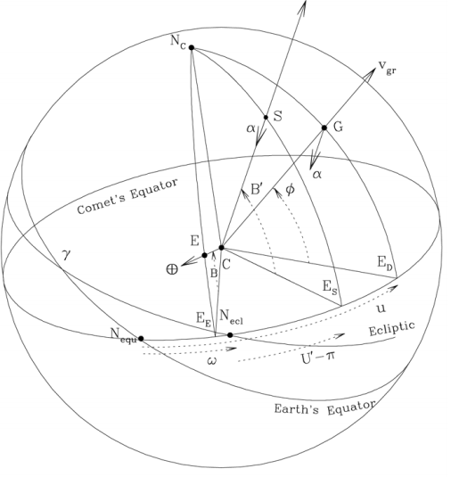

**Figure: Geometry indicating the location of the source G and the directions of the initial velocity vgr and acceleration α of the ejected grain. The sub-Sun point, sub-Earth point, and the North pole of the comet are S, E, and NC , respectively**

4.Activity Chart:

Plot the trajectories of each jet particle *wrt*. rotational motion of the comet

Model the motion of the ejection of the jets.

Model the Cometary Motion

Formulate the Equations

Simulate using C++ and Opengl

**PLOTTING THE TAIL STRUCTURE**

Input the simulation parameters

Get the data about orbital amount

Data needed are eccentricity, perihelion distance, inclination, longitude of ascending node, argument of perihelion, perihelion date in JD

With RA and DA as axis plot the Syndynes and Synchrones which gives us the tail geometry with respect to sun’s direction.

Process the data to get the simulation results in form Ephemeris

Analyse the data to pick out the features of dust and characteristic of tail

5.Implementation:

5.1. Modeling Of The Inner Coma

In the simplest model, the outgassing field around the comet is assumed to be produced by a single discrete jet located on the surface of the comet. More complicated models assume that the outgassing field is produced by multiple jets of varying strengths distributed across the surface of the comet nucleus. The single jet case is presented here. Multiple jets are modelled as copies of a single jet with varied parameters.

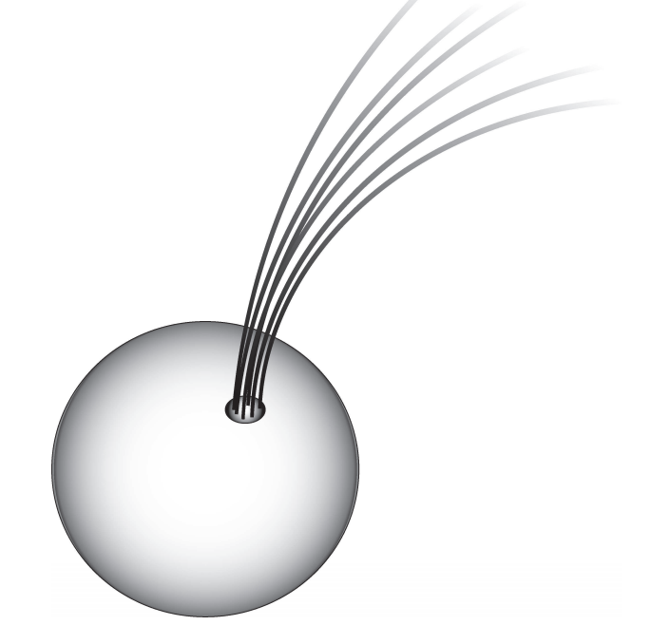

Figure: Outgassing Jet Illustration

The jet is assumed to be fixed on the comet’s surface with its center located at a radius from the center of the comet nucleus, r0, a longitude of φ0, and a latitude of λ0 in the comet body fixed frame. The active region on the surface of the comet is assumed to have a circular cross section which is defined by the size and shape of the jet by a constant half angle, δ, and radius on the surface , rp. For the purposes of this work, these jet parameters remain constant over time (including multiple perihelion passages) although realistically the jet geometry may change as a result of surface topological changes due to sublimation or other processes over long time spans. The outgassing is modelled as a constant gas velocity, Vog, away from the comet surface in a direction defined by the jet’s orientation which may point in any arbitrary direction away from the comet surface. The constant velocity is a reasonable approximation above one mean comet radius altitude while this assumption may not hold close to the comet surface where complex gas dynamics and interactions can occur. The simplest model used assumes that the orientation of the jet is the outward normal to the surface at the jet location although arbitrary orientations are occasionally used. In general, the spacecraft orbits do not interact with the jets close to the surface, therefore the constant velocity assumption holds for the trajectories considered in this research. To begin describing the three-dimensional geometry of the jet, we start with the center line of the outgassing jet which passes through the center of the jet at the surface as defined above. The center line is defined as a function of time since ejection, s, and can be expressed in the comet body fixed frame as :

rog(s) = r’*e*rsurf + Vogs*e*rjet ,

where ‘*e*rsurf’ is the body fixed unit vector pointing from the center of the comet to the jet surface point in the radial direction and ‘*e*rjet’ is the body fixed unit vector pointing in the jet orientation direction.

As previously mentioned, the comet body fixed frame is assumed, for now, to rotate at a constant rate, ω, with the comet nucleus and is transformed from (*x, y, z*), the non-rotating coordinate system with ˆz aligned along the spin axis of the comet, to the body fixed coordinate frame, (*xb, yb, zb*), by the rotation matrix, R(t).

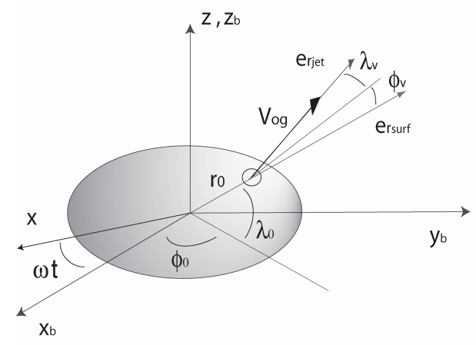

Figure: Coordinate Frames

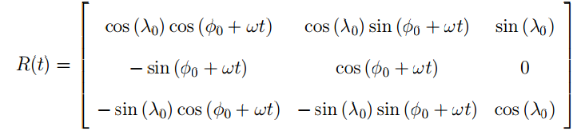

Therefore, the outgassing jet centerline, *r*og, can be expressed as a function of both the time, t, and the time since ejection, s, in the non-rotating inertial frame, (*x, y, z*), using the rotation matrix, R(t).



A second rotation matrix is used to transform this inertial frame to a frame corresponding to the comet’s heliocentric orbit. This calculation will not be presented here as it is a common transformation and can be found in any orbital mechanics textbook. Since a circular cross section is assumed for the jet, the surface of the outgassing jet is modelled as a curved cone that is defined by the constant half

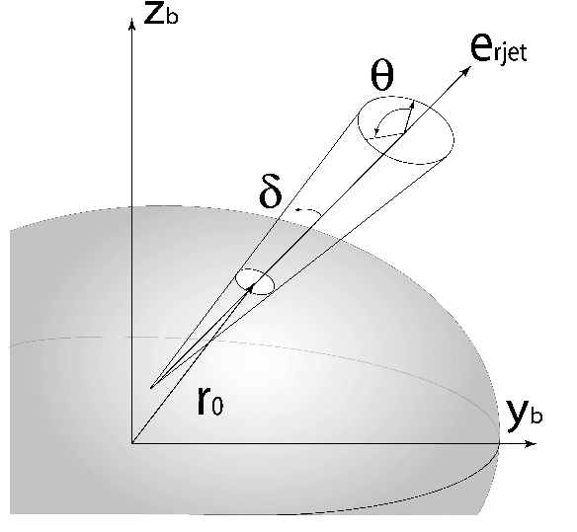

Figure: Outgassing Jet Surface

angle, δ, from the jet centerline as well as the time since ejection in the body fixed frame. The radius of the cross section at the surface of the comet, rp, completes the geometric description of the outgassing jet by defining a virtual origin of the jet centerline which in general will not coincide with the center of the comet’s nucleus and may actually reside outside the comet body. Figure 2.3 illustrates the geometry of the jet surface. Note that the cone will curve as the comet body rotates and that the half angle of the jet may diverge at large distances from the surface of the comet. The geometric description only provides part of the full outgassing jet model. To complete the model, the outgassing pressure field needs to be considered and defined. The jet generates a pressure field which is a function of the mass ejection rate per unit area, Qj , of the jet at the surface of the comet and the velocity of the material being ejected, Vog. The pressure of the outgassing at the surface of the comet, p0, is defined as:



The velocity field is assumed to be uniformly outwards in the direction of the jet’s orientation at the time of ejection, therefore a vector pressure aligned with the velocity field can be defined as:



This mass ejection rate, Qj , is estimated as:



where Q∗ is the mass ejection rate of a plane with an area equal to the surface area of the comet perpendicular to the Sun at a distance of 1 AU away, S is the relative intensity of the jet with respect to Q∗ defined by the jet’s active area relative to the comet’s surface area, θsun is the angle between the a unit vector in the direction of the Sun and the orientation vector of the outgassing jet, and rs is the heliocentric distance of the comet. This mass ejection rate is not constant but is dependent on the distance from the Sun as well as if the jet is sunlit or in darkness. As the comet travels closer to the Sun its thermal activity will increase as a function of rs yielding an outgassing strength empirically determined by:

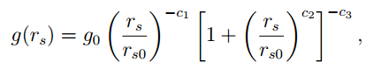

where c1 = 2.15, c2 = 5.093, c3 = 4.6142, rs0 = 2.808, and g0 = 0.111262. The function f(θsun) provides a relationship for the strength of the pressure at the surface of the comet as it is related to the angle the Sun makes with the orientation of the jet. If the unit vector pointing towards the Sun is defined as

*u*s, then cos θsun =*u*s · *r*og(t, s)

uses the function :

f(θsun) = 1 − α(1 − cos θsun)

with a restriction of α ≤ 1/2, and therefore f(θsun) never takes on a value of 0 in their theory. A conditional function f(θsun) provides for a stronger pressure when the surface is illuminated by the Sun and a weak (possibly zero) pressure when it is not, such that

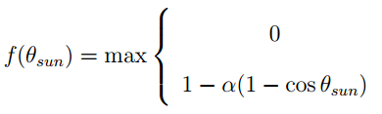

The parameter α is related to the thermal inertia, and can take on any numerical value of α such that 0 ≤ α ≤ 1. Note that if α ≤ 1/2, then the function simplifies to f(θsun) = 1 − α(1 − cos θsun) which is always greater than or equal to 0. Note that this pressure vector described is for the pressure at the surface of the comet. The pressure magnitude felt by the orbiter will depend on it’s radial distance from the comet’s surface. It is assumed to be inversely proportional to its radial distance and will diminish as 1/|rj | 2 , where rj is the spacecraft’s position vector relative to the virtual center of the jet, illustrated in illustrated in Figure 2.3. Therefore, the pressure vector at the spacecraft is defined as:

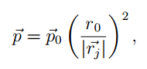

where |rj | > r0 is assumed. The pressure is felt as an acceleration on the spacecraft from the outgassing, and takes the form:

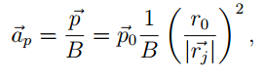

5.2. Finson-Probstein Dynamical Theory to Model the Syndynes and Synchrones

The motion of dust particles in a cometary environment is a complex process. A precise description of the grain trajectories requires advanced hydrodynamic models. In the tail, dust and gas are decoupled and the only significant forces affecting the grain trajectories are the solar gravity and radiation pressure. Both forces depend on the square of the heliocentric distance but work in opposite directions. Their sum can be seen as a reduced solar gravity, and the equation of motion is simply m × a = (1 − β) × Sungravity, where β is the ratio Pradiation/Sungravity, and is inversely proportional to the size of the grains for particles larger than 1 micron. From this relation, Finson & Probstein (1968, [7]) proposed a model which describes the full tail geometry with a grid of synchrones and syndynes, i.e., lines representing, respectively, the locations of particles released at the same time or with the same β. This model is simple because it considers only particles released in the orbital plane of the comet, and with zero initial velocity, but it provides a very good approximation of the shape of the tail, and has been used successfully to study many comets. One of the many strengths of this approach is the possibility to date events in the tail. For instance, one can understand if regions of higher density are related to outbursts of the nucleus, or are a result of fragmentation of large chunks of material within the trail. It can also be used to disentangle between continuous activity, short outbursts, or impacts, when all these events produce a feature which at first look like a normal cometary tail.

Diagram labelling Syndynes and Synchrones

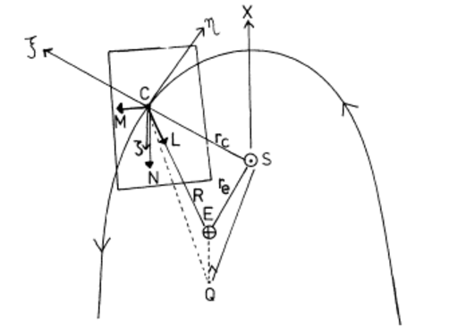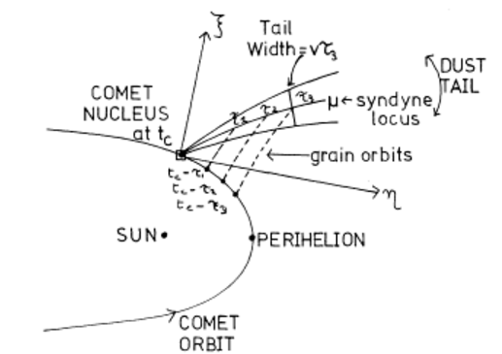

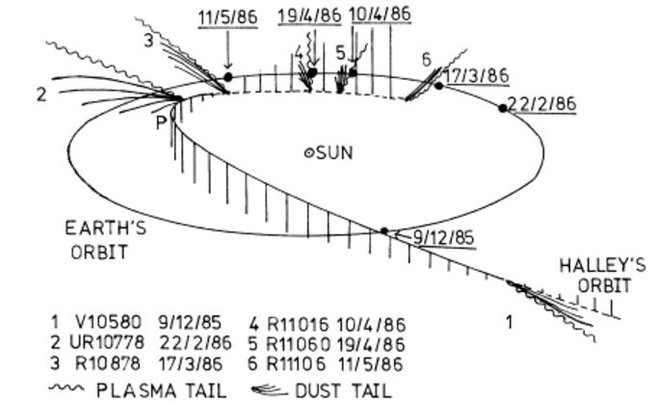

-----------------------------------------------------------------------------------

6.Description of Hardware and Software Requirements:

Additional Hardware Requirements:

1. Graphics Card (Supporting Opengl)

Software Requirements:

1. Operating System : Windows/Unix
2. Graphics Driver : Mesa Distribution Preferred in Unix Systems/NVDIA/AMD drivers.
3. Browser (Chrome/IE/Opera/…)

**Integrated Development Environment:** CodeBlocks 16.01, Web Browser

**Language:** C++, Java Script, Google Analytics, FLOT library.

**Graphical API:** Opengl

**Graphics Libraries:** opengl32, glu32, glut32

**Windows Library Header file:** <windows.h>

**Mathematical Library:** C++ Standard Library (<math.h> header file required)

**Prerequisites:**

1. Updated Graphics Driver
2. Correct Linker Settings in IDE(Linking of Libraries)

----------------------------------------------------------------------------------------------------

7.Result:

**7.1. Comet Nucleus Structure Model in Opengl using 3D object**

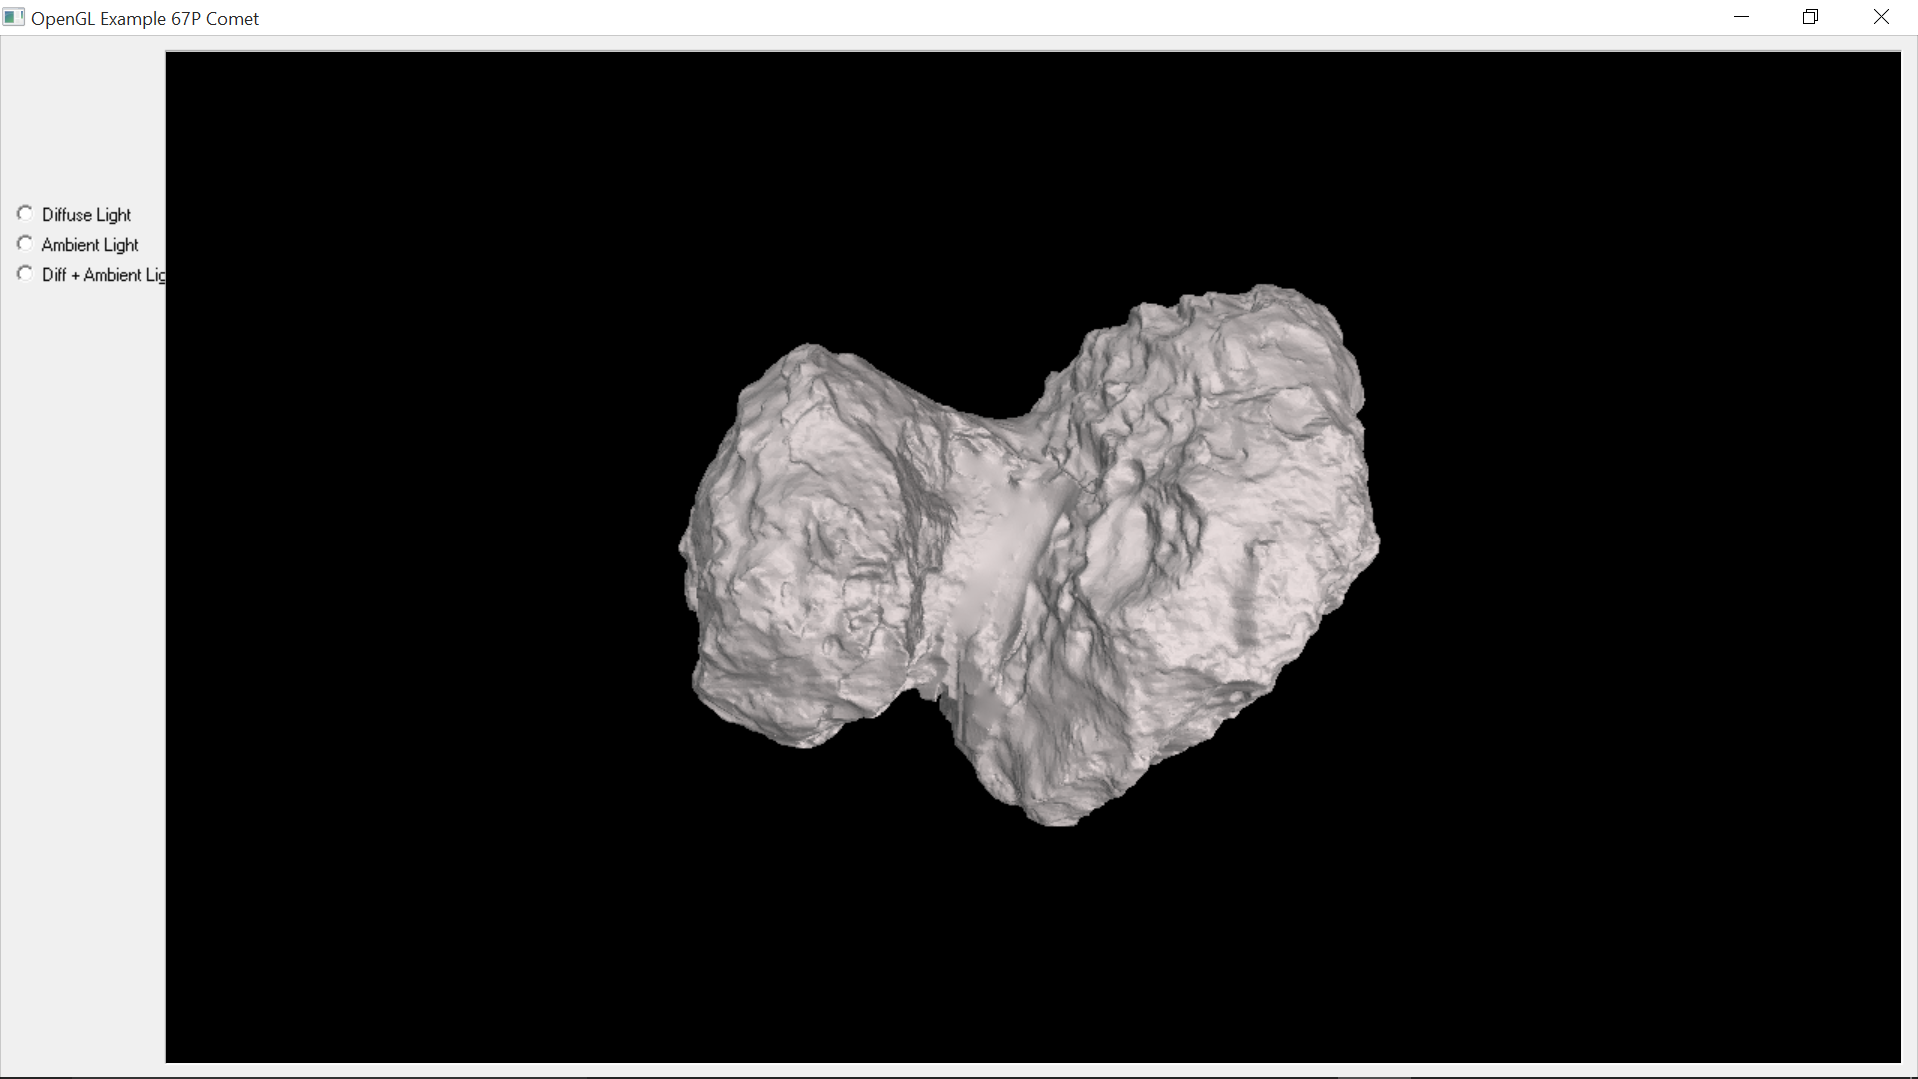

Figure: The above application uses a 3D satellite object Model to render the NUCLEUS of the comet. (Ref: Rosetta observation)

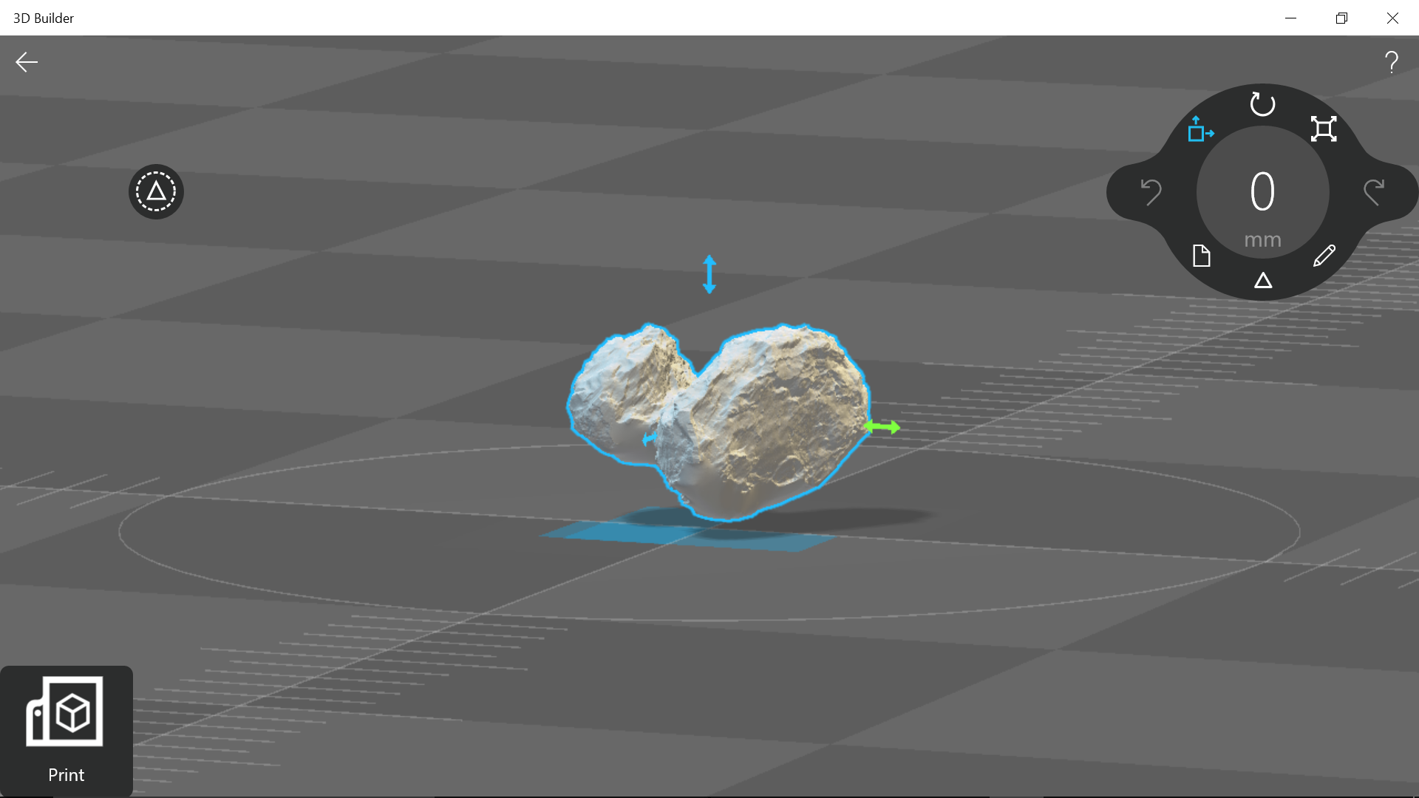

**7.2. Model of an Outgassing Inner Coma Cometary Jet:**

**7.2.1: System Defined:** A particle system class is defined which consists of maximum particle ejected, vector of particle objects. Particle objects also consist of the instance or current state information of the system down to the particles.

**Figures: Running Application Graphically Simulating an Outgassing Jet.**

1. **Gas particles B. Dust particles**

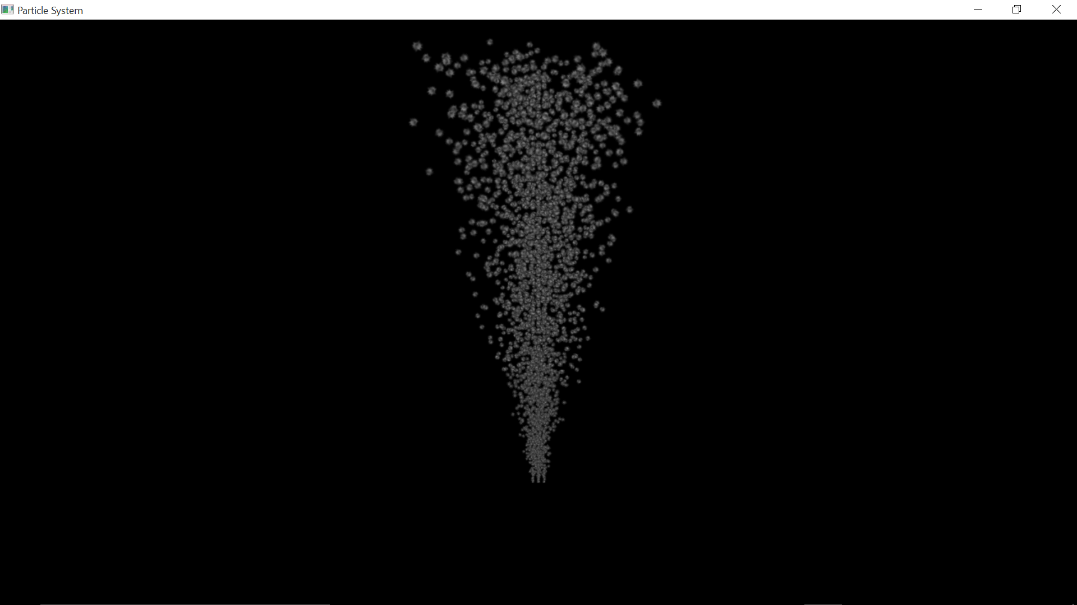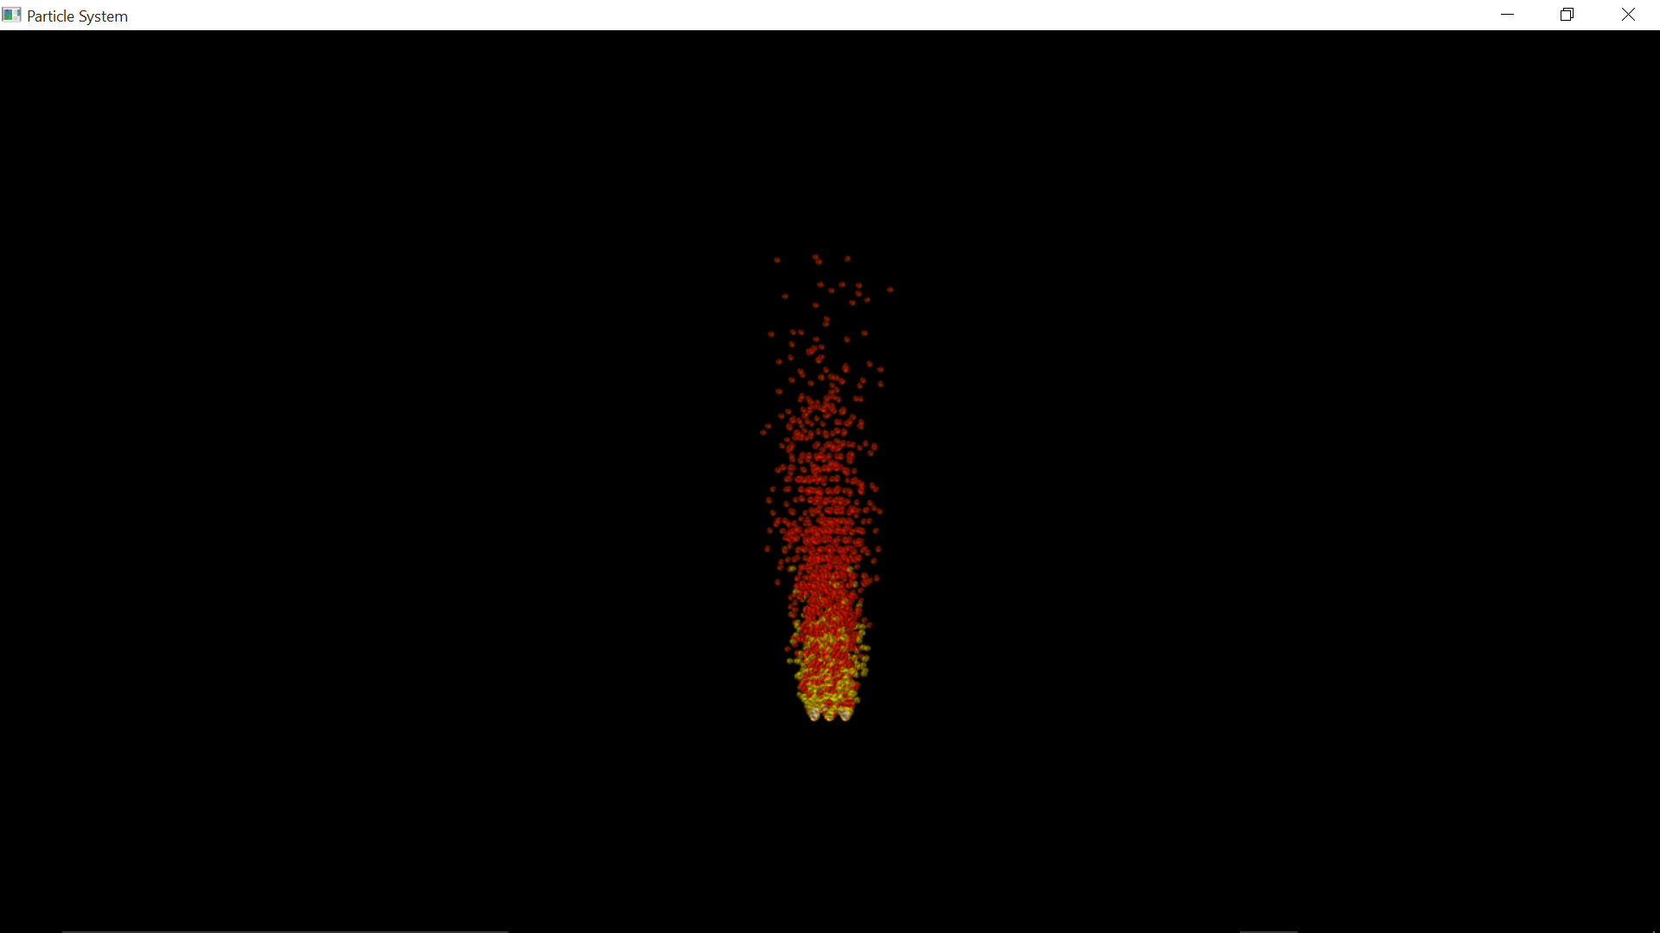

**Gas and Dust Particles Together**

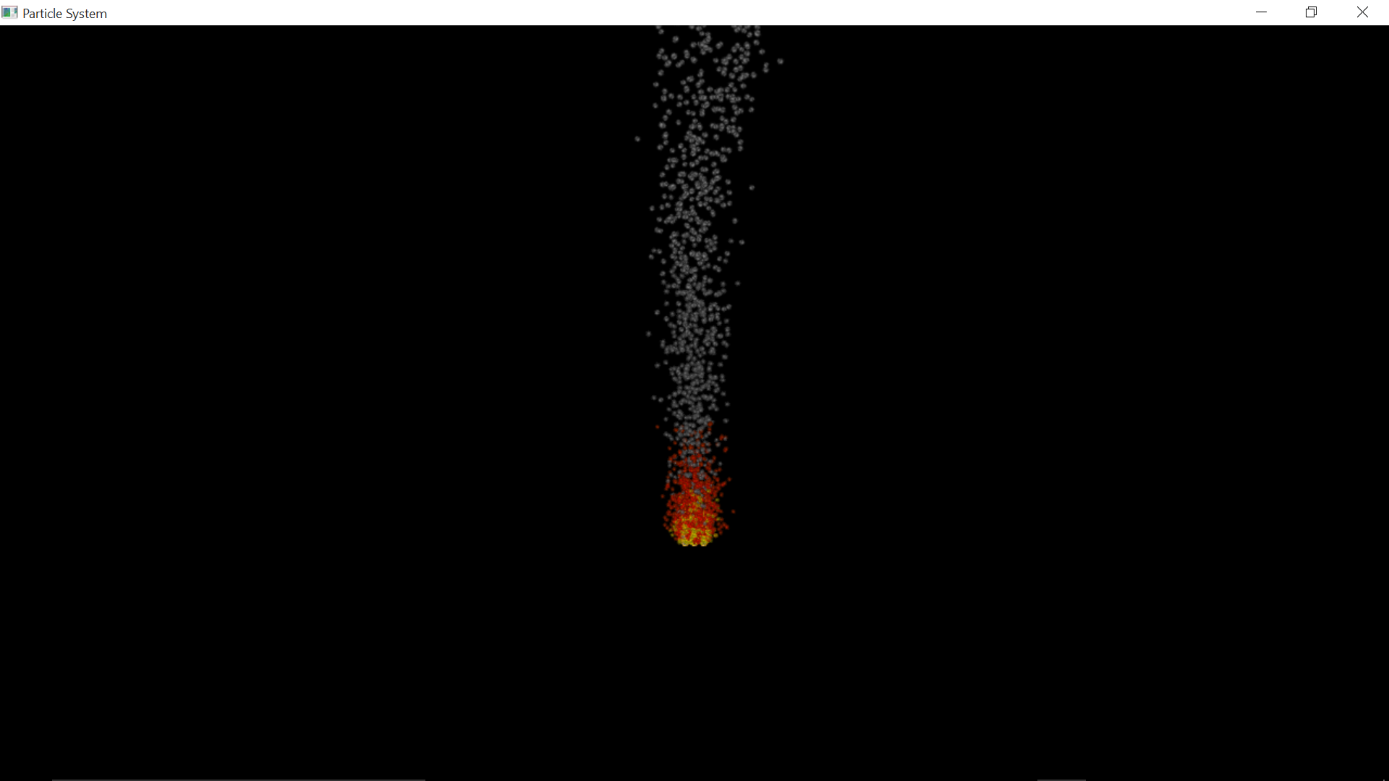

1. **Jet under Influence of Sun’s Radiation Pressure and Forces of Gravity**

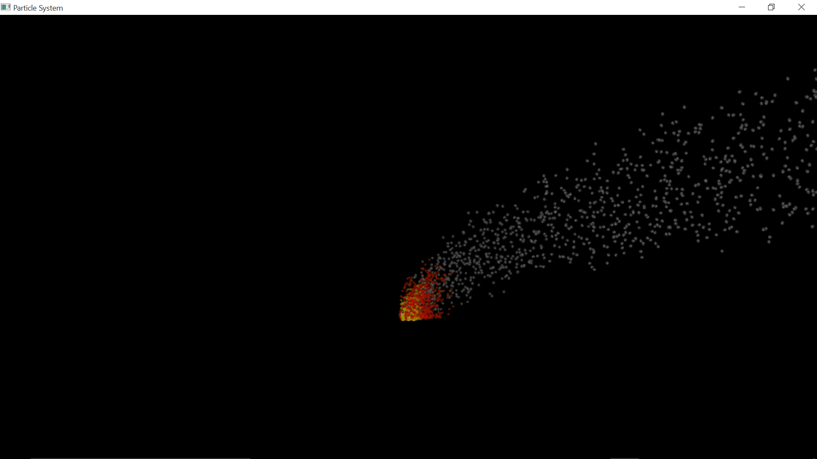

1. **Multiple jets under Solar Influence(Radiation and Pressure)**

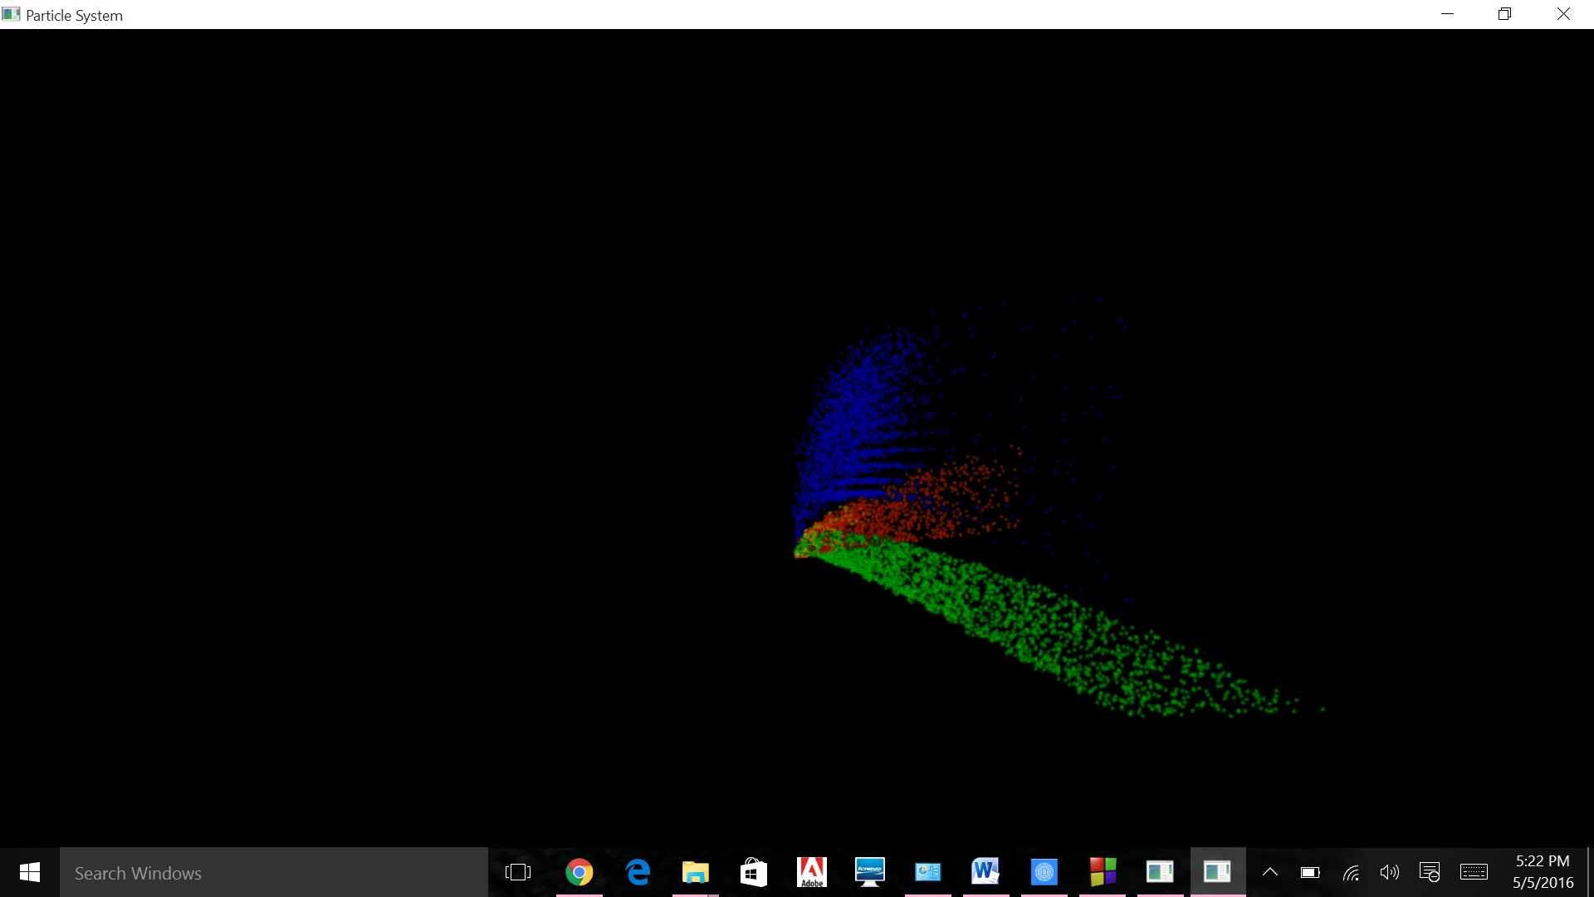

*Particle system with multiple emitters. Flexible to handle!*

**-------------------------------------------------------------------------------------**

**7.3. PLOT of Syndynes and Synchrones**

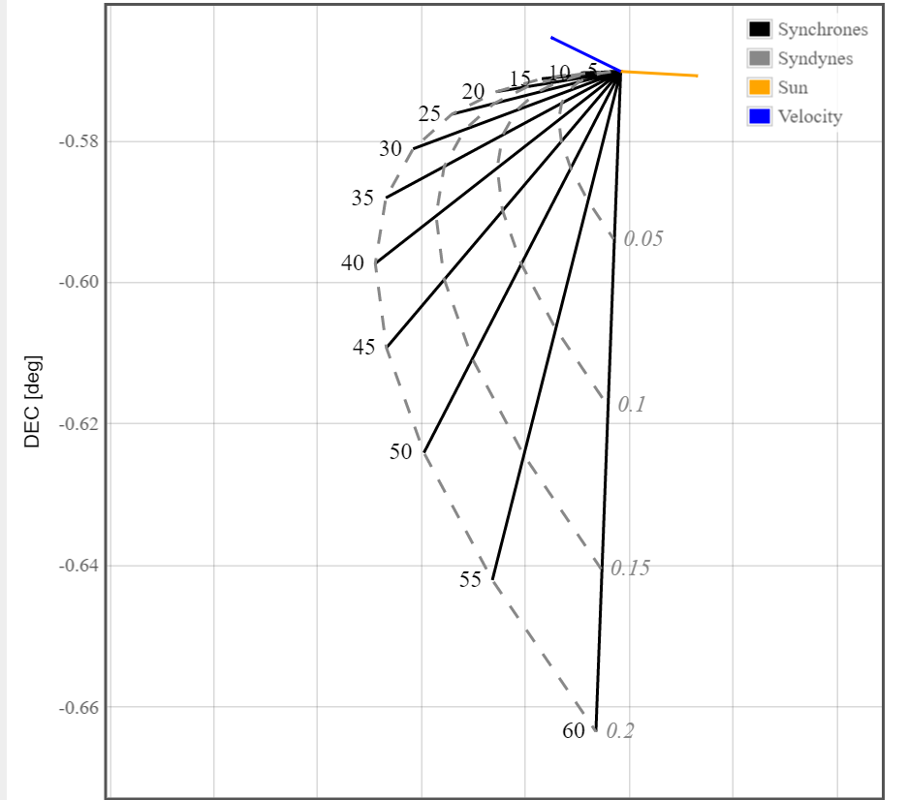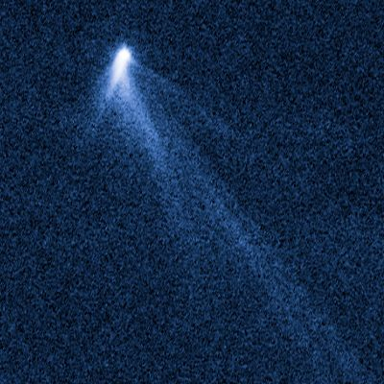

***Example Comet : Corresponding Syndynes and Synchrones forming shape of the tail***

**7.4. Comparing Simulation with Observed Images**

**7.4.1Comet Shells**

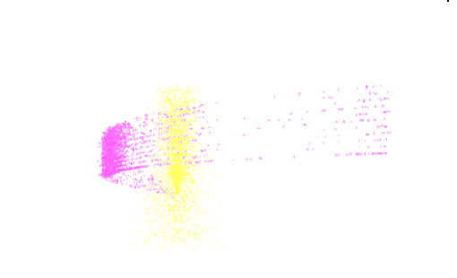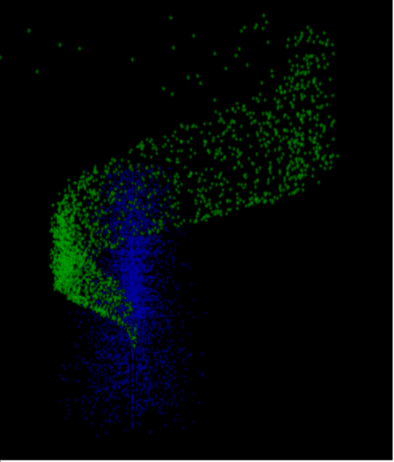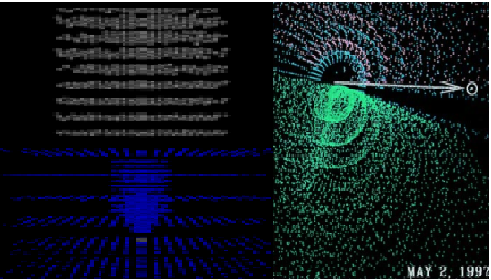

**7.4.2. Comparison of Simulated System and Observed System from Different Dimension**

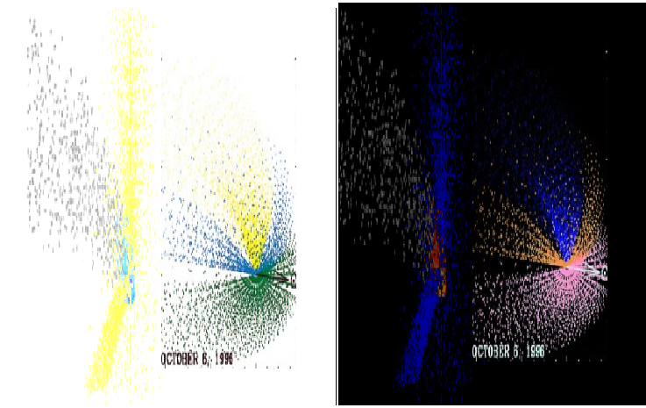

**7.4.3 Superposed Images at an Instant**

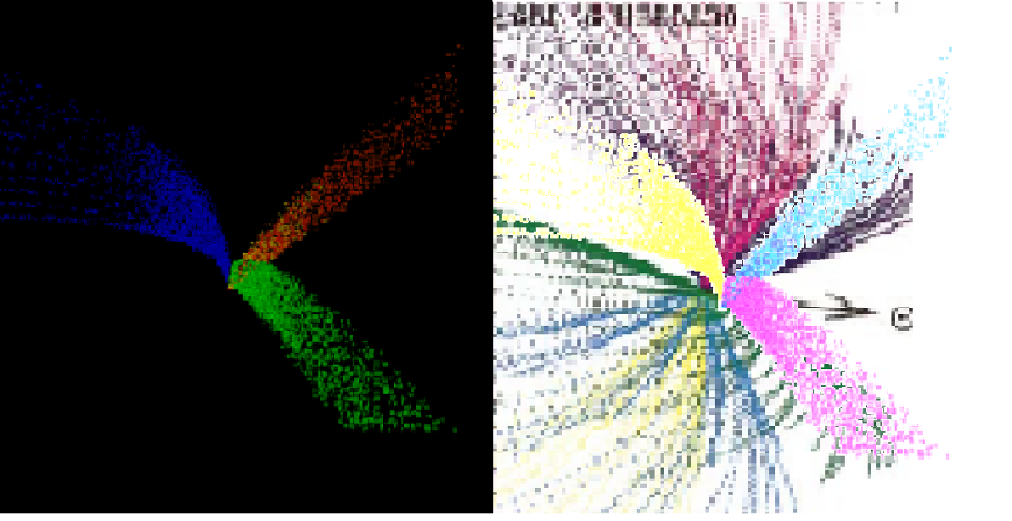

8.Limitations:

a) There may be errors but must be efficiently handled by third party error correction applications.

b) Astrophysics aspects of the solar system are out of scope of our project, we are concerned with the computer simulation.

c) We are not going into details of image processing, plots are used merely for representation.

9.Future Scope of our Project.

1. To get deeper into the surface study of the comet.

2. Simulation of Multiple Jets from a comet under influence of :

a. Neighbouring Gravitational Forces

b. Solar activities.

c. Motion of Comet.

3. Study of comet orbits and motion of spacecraft around a comet in a constructed orbit.

10.References:

[1] R.Vasundhara and Pavan Chakraborty “Modeling of Jets from Comet Hale–Bopp (C/1995 O1): Observations from the Vainu Bappu Observatory” Indian Institute of Astrophysics, Bangalore 500034, India

[2] Sharyl.M.Byram “The Effects of Dust Trajectory” Indian Institute of Information Technology, Allahabad 211012, Uttar Pradesh, India.

[3] Sekanina, Z., and S. M. Larson 1984.” Coma morphology and dust emission pattern of periodic Comet Halley. II. Nucleus spin vector and modeling of major dust features in 1910”. Astron. J. 89, 1408–1425.

[4] [SAO/NASA Astrophysics Data System (ADS)](http://www.adsabs.harvard.edu/)

Title: The application of Finson-Probstein dynamical theory to the dust tail of P/Halley  
Authors: Birkett, Journal: Monthly Notices of the Royal Astronomical Society (ISSN 0035-8711), vol. 235, Nov. 15,1988,p.497-521.Bibliographic Code: 1988MNRAS.235..497B

--------------------------------------------------------------------------------------------------------------------------------------------------